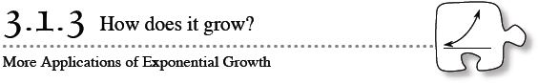
You may have heard the expression, “Money does not grow on trees.” However, money does, in a sense, grow in a savings account. In today's lesson you will apply your understanding of exponential functions to solve problems involving money and interest.
3-34. SAVING FOR COLLEGE
Suppose you have $1000 to invest and know of two investment options. You can invest in bonds (which pay 8% simple interest) or put your money in a credit-union account (which pays 8% compound interest). Will the option you choose make a difference in the amount of money you earn? Examine these two contexts below.
Bonds with Simple Interest:
  - If you invest in bonds, your $1000 would grow as shown in the table below. How does money grow with simple interest?
VALUE OF BONDS
Number of Years | Amount of Money (in dollars)
0 | 1000.00 (initial value)
1 | 1080.00
2 | 1160.00
3 | 1240.00
4
  - By what percent would your balance have increased at the end of the 4th year? Show how you know.
Accounts with Compound Interest:
  - Instead, if you invest your $1000 in the credit union at 8% compound interest that is compounded once a year, its value would grow as shown in the table below. Why is there $1166.40 in your account at the end of the second year? Explain how the money grows with compound interest.

VALUE OF CREDIT-UNION ACCOUNT

Number of Years | Amount of Money (in dollars)
0 | 1000.00 (initial value)
1 | 1080.00
2 | 1166.40
3 | 1259.71
4
  - What will be the balance of the credit-union account at the end of the 4th year? By what percent would this account balance increase in four years? Show how you know.
  - Which type of account — a bond with simple interest or a credit-union account with compound interest — grows most quickly?
  - How much would your original $1000 investment be worth at the end of 20 years in this credit union? Show how you got your answer.
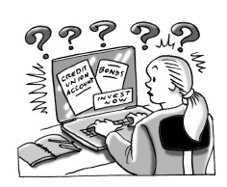
- 3-35. Examine these two types of investments through other representations below.
  - The sequence below represents the value of an investment earning simple interest at the beginning of each year.
1000, 1080, 1160, 1240, …
Is this sequence arithmetic, geometric, or neither? What calculation is done to each term to get the next term?
  - Write a sequence for the value of the investment when $1000 is invested in an account with 8% annually compounded interest. Is this sequence arithmetic, geometric, or neither? What calculation is done to each term to get the next term?

  - Write an equation for each type of interest (simple and compound), where y represents the value of the investment after x years.

  - For each type of investment (simple and compound), draw a graph showing the value of $1000 over the first 8 years. Should these graphs be discrete (points only) or continuous (connected)? Explain.

  - What interest rate would the bonds with simple interest need to earn so that you would earn the same amount in both accounts after 6 years? After 20 years? Show how you know.

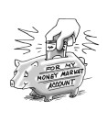
- 3-36. A third option for investing money is a money-market account, which offers 8% annual interest compounded quarterly (four times per year). This means that the 8% is divided into four parts over the year, so the bank pays 2% every three months.
  - Represent the value (at the end of every three months) of the $1000 investment in this money-market account with a sequence. List at least six terms.
  - Write an equation that determines the value of the investment, y, in the money-market account after x quarters.

  - What will be the value of your $1000 investment at the end of four years? How does this compare with your other investment options?

- 3-37. You have $500 to invest and have several options available to you.
  - Your banker shows you the graph below to explain what you can earn if you invest with him. Does this graph represent simple or compound interest? How can you tell? What is the interest rate? Write an equation to represent how much money you would have as time passes. Let x represent time in years.
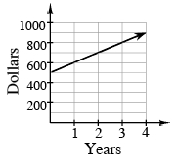
  - Jerry says, “I've got my money in a great account that compounds interest monthly. The equation y = 388(1.008)^{m} represents how much money I have at the end of any month.” What is Jerry's annual interest rate? Write an equation to represent your total money if you invest your $500 in an account with the same rate of return. Let m represent the number of months the money has been invested.

  - An investment advisor shows you the table of earnings you see below. Write an equation for the table, letting q represent the number of quarters the money has been invested. What is the annual interest rate?
Quarter | $
0 | 500
1 | 515
2 | 530.45
3 | 546.36
  - Compare the earning potential of the options described in parts (a), (b), and (c) above. Which account is the best investment if you plan to leave your money in for only one year? Which would grow the most after ten years? Show and explain your work.

