Matrix practice Name_______________________
Let G be the matrix shown below.
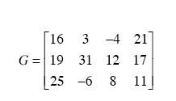
  - What is g_{1,3}

  - Two matrices can be added only if they have the same dimensions. If matrix H can be added to matrix G, what must be the dimensions of H?

  - All the entries of the zero matrix are 0. Write the zero matrix with the same dimensions as G.

  - Create a matrix to add to matrix G to get the zero matrix. This is called the additive inverse of a matrix. What could you name your new matrix to show its relationship to G?

Shola's Bakery uses sugar, eggs, and butter in all of its cakes, as well as in the frosting. Matrix C shows how many eggs, cups of sugar, and ounces of butter are used in each angel food cake and in each devil's food cake. Matrix F shows how many eggs, cups of sugar, and ounces of butter are used in the frosting for each cake.
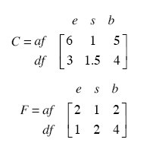
  - Write the matrix C + F, being sure to label the rows and columns, and explain what it represents.

  - Write the matrix 3C, with labels, and explain what it represents.

  - Leora orders three angel food cakes and two devil's food cakes without frosting, as represented by the matrix L at right. Use matrix multiplication to write a matrix that shows how much sugar, eggs, and butter Shola will need to fill Leora's order.
